Team Bravo Request for Proposal

Saint Louis University



by

Jennifer Babb

Bryant Gaume

Tyler Olson

Tom Moline

Nate Richard

Copper Operational

Test Plan

# Mission Introduction

Team Bravo is requesting proposals for a mission consisting of a CubeSat-Class satellite system that is capable of demonstrating three key proximity operations relative to a resident space object: stationkeeping, “escape” maneuvers, and rendezvous. Table 1-1 lists the definition of each of these proximity operation terms, while the Appendix discusses in detail general terms associated with any CubeSat mission.

**Table 1-1. Key Proximity Operations Definitions**

|  |  |
| --- | --- |
| **Proximity Operation Terms** | **Definition** |
| Stationkeeping | Maintaining a set relative displacement between two space objects for a period of several orbits |
| “Escape” Maneuver | Performing an orbital maneuver that increases the relative displacement between two space objects, as to avoid on-orbit collisions and potential orbital debris creation. |
| Rendezvous | Performing an orbital maneuver that decreases the relative displacement between two space objects within a set distance for a period of several orbits. |
| Resident Space Object | Any satellite or space debris residing in an orbit around the Earth. |

Along with performing each of the above proximity operations, the proposed mission has several other limits on its successful implementation. These constraints are associated with the launch capabilities of current launch providers (Such as Space X, Orbital Science, United Launch Alliance, etc.), past CubeSat launch history, a required 25 year mission deorbit time (As specified in the *NASA-STD-8719.14A* Document) and standard specifications laid out in Revision 12 of the *CubeSat Design Specification* (CDS) document issued by California Polytechnic State University’s CubeSat Program, the current authority on CubeSat mission launch integration.

**Based on these design considerations, each particular constraint can be specified as follows:**

* **Lifetime:** To accomplish all of the mission goals, it is reasonable to set a minimum mission lifetime of six months.
* **Deorbit Time:** Along with this, the proposed mission must also be capable of deorbiting within 25 years of its launch.
* **Launch Survival:** The standard method of verifying that a particular satellite can survive its launch environment is to subject it to random vibration testing. Since the final launch provider for the proposed mission is unknown, a standard vibration profiles must be used that accounts for any current launcher, such as the NASA GEVS (General Environmental Verification Standard) qualification profile, as defined in Revision A of the *GSFC-STD-7000* document.
* **Thermal Operational Range:** The proposed mission must be able to function in any temperature range it may experience over the course of its lifetime.
* **System Mass:** Finally, a maximum system mass of 8 kg can be set, as defined by the CDS.

These mission constraints are summarized in Table 1-2 below:

**Table 1-2. Proposed Mission Constraints**

|  |  |  |  |  |
| --- | --- | --- | --- | --- |
| **Mission Lifetime** | **Deorbit Time** | **System Size** | **Launch Survival Verification** | **System Mass** |
| 6 Months | < 25 Years | 6U | NASA GEVS Qualification Random Vibration Profile | 8 kg |

# Mission Overview

With the constraints discussed in the previous section in mind, the objective and success criteria of the proposed mission can be defined as follows:

## Mission Objective

**The proposed mission shall demonstrate proximity operations and rendezvous within a 6U spacecraft architecture.**

## Mission Success Criteria

**The proposed mission shall demonstrate:**

1. Stationkeeping within a 10-75 m sphere of a resident space object for at least 5 orbits.
2. An “Escape” Maneuver by performing an orbital maneuver that intentionally increases the final relative displacement between the mission spacecraft and a resident space object to at least 100 meters in a maximum time of 1 orbit.
3. Rendezvous by performing an orbital maneuver that intentionally decreases the final relative displacement between the mission spacecraft and a resident space object to within 50 m for a period of time of at least 5 orbits.

# Appendix

It is important to establish the meanings of various terms that are associated with any given CubeSat mission, such as the one proposed in this document. Firstly, 1U, or one standard unit, is defined as a cube of a uniform edge length of 10 cm. A CubeSat-Class satellite (aka a “nanosatellite”) is a satellite whose dimensions derive from 1 or more of these standard units. As an example of this particular satellite configuration, a 3U sized spacecraft is shown in Figure 3-1 below.

The reason for creating such satellites is twofold: it greatly reduces the time and monetary investment associated with developing custom satellite shapes and structures, while also allowing the development of standard satellite deployers for integration into any rocket configuration, thus allowing greater access to launch opportunities for university missions. Currently, the largest volume CubeSat deployer is the NLAS (Nanosatellite Launch Adapter System) deployer, which has space for a 6U satellite configuration.

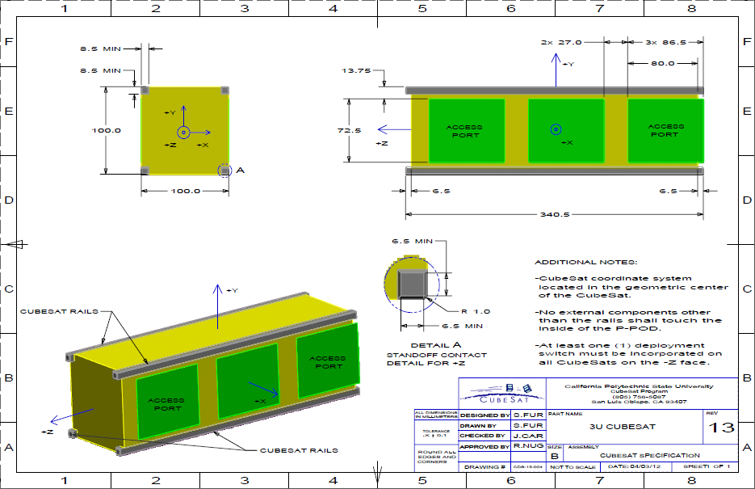

**Figure 3-1. Example 3U CubeSat Architecture**